Smart Social Media

School Promotion Materials

Sample social media posts
The following posts are example posts that schools may choose to use and adapt to update their school communities about changes to practice and to promote respectful and responsible social media use within the wider community.

Sample Post: Announcing changes to social media use
📢 We’re updating how we share online!  Our school is committed to responsible, respectful, and intentional use of social media. That means putting children’s privacy, safety, and rights at the center of everything we share.  Over the next term, you’ll see small changes to the types of images and information we post. These changes are guided by national research‑informed principles to support safe, respectful sharing <https://digitalchild.org.au/principles-social-media-education>.  Thank you for supporting our school community as we model positive digital behaviours for our students, families and teachers. | 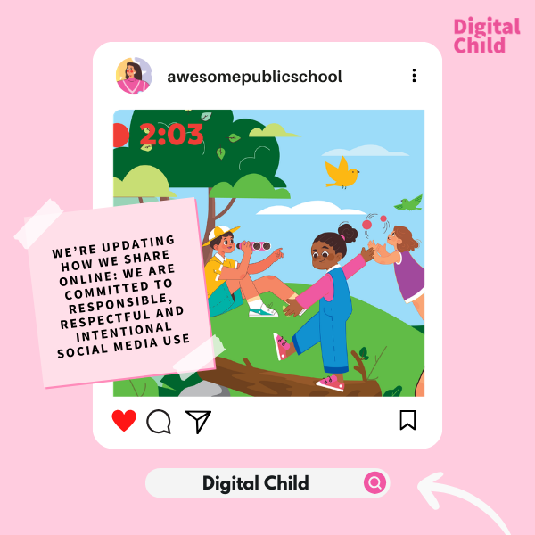

Sample Post: Communicating revised purpose of social media use
📢 Less posting, more purpose  We’re updating how we share online. That means using each communication platform thoughtfully and reducing the volume of posts shared across multiple channels.  Our social media pages will now be used for:  🎉 School highlights and celebrations  📅 Key updates and reminders  💡 Community messages  More personal or detailed communication will be shared through [insert details].  This helps reduce unnecessary sharing of student information while improving communication for families. If you have any questions or feedback about these changes, please contact [contact details]. | 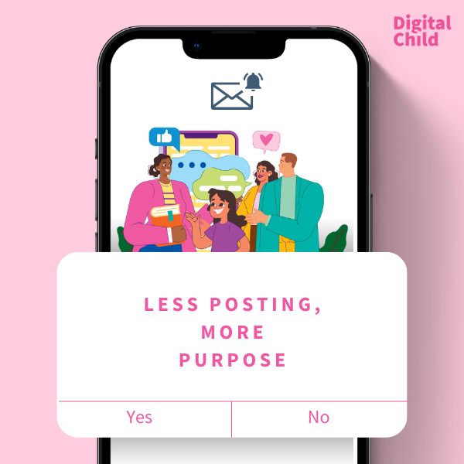  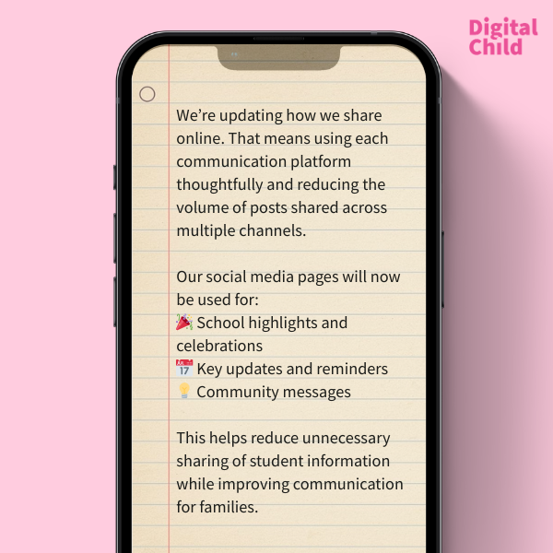

Sample post: Communicating focus on minimisation of personal data
️🛡️ Protecting student privacy - our renewed commitment
We are shifting our social media use to focus on activities and learning, rather than identifiable images of students.
This means:
✔️ Fewer photos of individual students
✔️ More photos of hands‑on learning, group shots, and class activities
✔️ No full names or personal details in posts
These changes help us minimise children’s digital data while still sharing the wonderful learning happening at school. We will continue to use [platform] to share more personalised updates and celebrations of student learning and achievements. If you have any questions or feedback about these changes, please contact [contact details].
Thank you for helping us keep our students safe online.

Sample post: Promoting partnering with families
🤝 Working together for safer digital sharing  Our community plays an important role in supporting safe and respectful online practices. We invite families to take up these strategies at school events.  By working together, we’re creating a safer digital environment for all children.  Learn more about the principles guiding our new approach <https://digitalchild.org.au/principles-social-media-education > | 