STEM ES1 weather learning sequence

## Resource considerations

This lesson sequence allows for continuity of student learning and could be adapted to fit in with your existing teaching and learning program.

* Students will be supported to meet outcomes from specific Key Learning Areas.
* Most tasks have a duration of approximately 30 minutes and could be used in conjunction with your framework, designed using the K-6 template.
* This lesson sequence uses a balance of synchronous and asynchronous learning strategies.
* The tasks provide options for students with and without technology. They can be used with any online platform.
* Assessment strategies linked to the success criteria are included to ensure evidence of learning is monitored and collected.

Resource considerations connect with other policy documents and processes with a focus on delivery and compliance.

## ****Learning sequence overview****

Students will identify different types of weather and how the weather changes. Students will identify a place to play and how the weather affects its use. Students will design a solution to an authentic problem for their favourite toy: How can I protect my favourite toy from the changes in weather? Students will apply their knowledge of measurement and number within the design solution.

There also seems to be a very broad purpose. It makes the task open but increases its complexity in terms of the multiple scientific concepts included, for example, the concept of sun versus rain protection.

Given the focus on creativity and imagination, it is surprising not to see outcomes related to storytelling, creativity, play

|  |
| --- |
| **Driving question: How can I protect my favourite toy from the changes in weather?** |
| **Key concepts:** Science and Technology: daily changes in the weather; Mathematics: measurement – length; Geography: **students understand that the places they belong to, and are important to them, may be similar and different for other people.**  **Key language** – weather, sunny, cloudy, rainy, windy, stormy, warm, hot, cool, cold, change; Mathematics: length, end, long, longer than, longest, short, shorter than, shortest, high, higher than, highest, tall, taller than, tallest, low, lower than, lowest, the same as, near, nearer, far, further, close, closer |

## Syllabus outcomes

Science and Mathematics are key areas for consideration, with the addition of a focus on *place* through the addition of Geography.

### Science and technology

**STe-2DP-T** – develops solutions to an identified need

**STe-6ES-S** – identifies how daily and seasonal changes in the environment affect humans and other living things

### **Mathematics**

**MAe-1WM** – describes mathematical situations using everyday language, actions, materials and informal recordings

**MAe-2WM** – uses objects, actions, technology and/or trial and error to explore mathematical problems

**MAe-3WM** – uses concrete materials and/or pictorial representations to support conclusions

**MAe-4NA** – counts to 30, and orders, reads and represents numbers in the range 0 to 20

**MAe-9MG –** describes and compares lengths and distances using everyday language

### **Geography**

**GEe-1** – identifies places and develops an understanding of the importance of places to people

Open-ended problem-solving process approach

## Aim of lesson sequence

This STEM learning sequence enables students to inquire, plan investigate and develop solutions to an authentic problem posed: How can I protect my favourite toy from the changes in weather? They will apply their understanding of scientific concepts of the effects of changes of weather. They will apply their understanding of mathematical concepts of measurement and number. They will apply their understanding of geographical concepts as they explore the interactions between people and places.

## Teacher notes

This learning sequence aligns with three Early Stage One learning sequences published on the NSW Department of Education Learning from Home website: science and technology (earth and space), mathematics, and geography (people in in places).

Useful syllabus connections. To STEM syllabus documents. Perhaps a connection to Literacy/Creative Arts Syllabus could help with creative and empathetic thinking through personal connection and story.

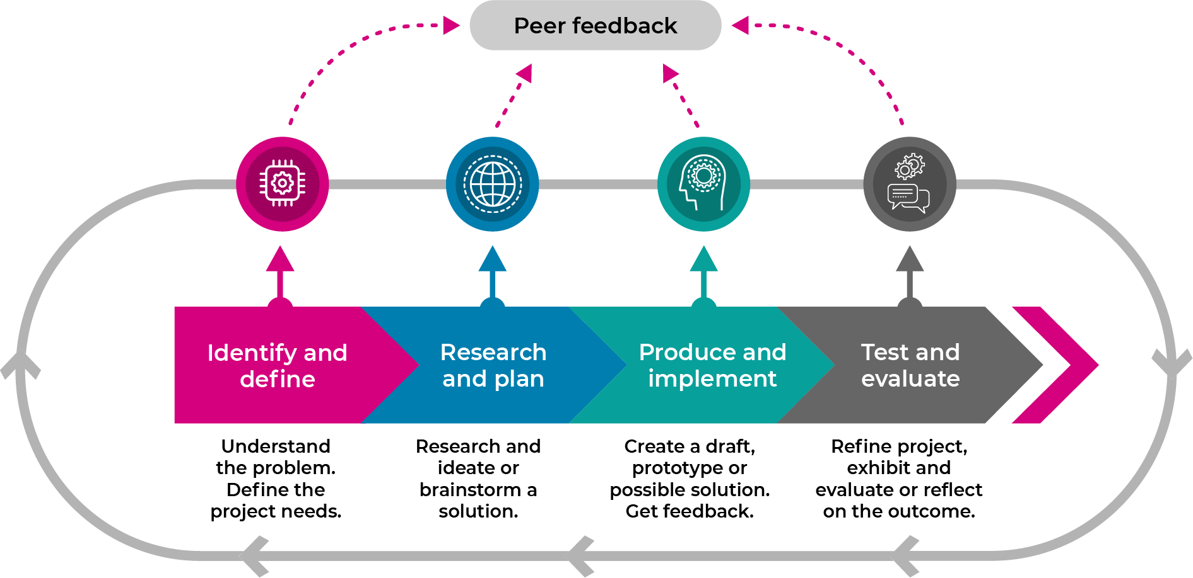

This learning sequence models an integrated approach to learning where the student solves an authentic problem by employing [design thinking skills](https://schoolsequella.det.nsw.edu.au/file/ba43743b-baca-4dd2-9689-2da09ad2ffc7/1/design-thinking-across-the-curriculum.zip/index.html#/).

* + Build the **empathy** of the student to the focus of the problem: the toy being left out in the weather.

Developed through storytelling?

* + **Identify and define** the task: the types of weather, what it may mean to protect something
  + Develop the skills of ideating: imagine, create and express new and innovative ideas (often in a rapid format)

Are there outcomes to support this requirement?

* + Allow the student to prototype (produce and implement) their idea: experimenting with solutions
  + Test and evaluate the validity of the solution: allow for refinement
  + Share: interrogate the solution with lots of praise and support

## ****Activity 1****

### **Science: Let’s talk about the weather**

* Review weather chart recorded in the STEM ES1 student workbook (see p 11 in this document). Discuss predictions of the weather.
* Search magazines for pictures of people outside on a sunny day, a cold day and a rainy day. Cut out and glue down the pictures into the STEM ES1 student workbook
* Share ideas about the clothing and the protection that people are needing for different weather. Focus on the following topics.
  + Wet weather – clothing such as a raincoat and gumboots, protection such as an umbrella
  + Hot weather – clothing such as shorts, t-shirt and sandals, protection such as a hat, sunglasses and sunscreen
  + Cold weather – clothing such as a jumper, coat and boots, protection such as scarf, beanie or even snow goggles
  + Ask: Are there other ways to protect us from the weather?

There seems to be an assumption that the learners know about the purposes and affordances of each item.

Extra information could help to understand the **purposes** of these decisions and **protective features** of the materials being chosen:

* Why do people make these choices?
* What it is that makes these choices protective? That is, what are the features of these materials?

**Activity 2**

### **Geography: Let’s talk about your play place**

#### **Digital activities**

* Take a photo of a place in the natural environment where they are allowed to play.
* Print the photo, draw a picture of themselves in the play space, and label the play spaces (for example, cubbyhouse, lawn, swings).

Why are digital and non digital activities listed separately?

* Glue photo into the STEM ES1 student workbook.

#### Non-digital activities

* Draw a picture in the STEM ES1 student workbook of a place outside the student’s home where they are allowed to play such as balcony, backyard or park
* Label the objects in the play spaces (for example, cubbyhouse, lawn, swings).

The Geography Outcome recommended here states: *identifies places and develops an understanding of the* ***importance of places to people***

Good opportunity to consider the nature of their spaces, why they’re preferred, who uses it and so one…as well as the possibilities they offer – a personal connection through stories.

### Mathematics: Let’s measure your play space

* Use everyday language to describe the length of the play space (for example, long, short, high, tall, low).
* Use comparative language to describe length of the sides, for example longer, longest, the same as.
* How many of your footprints (heel to toe) is needed to measure the longest side of your play space?
* How many of your footprints (heel to toe) is needed to measure the shortest side of your play space?
* How many footprints (heel to toe) from the biggest object to the smallest object?
* Record the number of footprints in your STEM ES1 student workbook
* Use everyday language to describe distance from the play space to other objects in the backyard, park or home for example near, far, nearer, further, closer
* Record which object is closest to them

Consider the connection to the purpose of the task – developing protection for the toy. Additional questions/prompts could connect back to the task:

* What are the play activities you like to do here with your toys?
* How do you use different parts of this space during different weather?
* What would you have to think about if you brought your toys here?

## Activity 3

### STEM: **Let’s talk about your toys**

* What are your favourite toys?
* Do your toys need to be protected from the weather?
* What would happen to your toy if it was left out in the hot/cold/wet weather?
* What would your toy need to protect it from the weather?

### Mathematics: **Let’s measure your favourite toy**

* Draw your favourite toy.
* Measure your toy with a teaspoon, peg or a building block.
* Record the number of spoons in your STEM ES1 student workbook
  + How many teaspoons, pegs or building blocks tall is your toy?
  + How many teaspoons, pegs or building blocks long is your toy?
  + How many teaspoons, pegs or building blocks wide is your toy?

### **STEM: Let’s imagine about our toy**

Could toys have positive and negative responses here? The term “weather” is broad and perhaps ambiguous given that there’s always weather, while the term “left out in the weather” carries a different connotation of being excluded or neglected.

Imagine if your toy was alive, what might it:

* ‘Say’ about being left outside in the weather?
* ‘Think’ about being left outside in the weather?
* ‘Feel’ if it was left outside in the weather?
* ‘Do’ about being left outside in the weather?

Complete the empathy map in STEM ES1 student workbook with drawings and labels of your toy in think, feel, say and do

## Activity 4

### STEM **(identify and define, research and plan): Let’s talk about our question and create ideas**

**How can I protect my favourite toy from the changes in the weather?**

* **What does it mean to protect something?**
* **What is your favourite toy?**
* **What does it mean for something to change?**
* **How does the weather change?**
* Quickly draw 4 ‘crazy’ ideas to protect the toy from changes in weather in STEM ES1 student workbook –encourage rapid, innovative ideas
* Share your ideas with the teacher or parent.
* Select your best idea.

Perhaps this is a place to sharpen the focus on exploration of the features of certain types of weather, (e.g., heat) so that technical knowledge and language can be explicitly developed, which would inform subsequent design and action.

An interesting outcome from that kind of focus could be on the ways different creatures protect themselves from the sun (for example) with mud or fur etc.

## ****Activity 5****

### **STEM (prototype/test): Let’s make and test your best idea**

#### **Digital activities**

* Make (engineer) your best idea that protects your toy from the weather using materials found at home or school (a making box) such as cardboard boxes, cylinders, tape, glue, pipe cleaners, materials, empty PET bottles, or any other resources that you can find
* Test your innovation in all types of weather. Here are some ideas for you to try.
  + A shower of rain (leave your toy under its protection and use a watering can or hose).
  + A hot day (leave your toy under its protection in the sun).
  + A cold day (leave your toy and its protection in the refrigerator for the night).
* Take photographs of your toy and its protection in the 3 kinds of weather
* Print them out.
* Paste them into your STEM ES1 student workbook.
* **Describe the results of your tests. Was your toy protected?**

#### Non-digital activities

* Make (engineer) your best idea that protects your toy from the weather using materials found at home or school (a making box) such as cardboard boxes, cylinders, tape, glue, pipe cleaners, materials, empty PET bottles, or any other resources that you can find
* Test your innovation in all types of weather. Here are some ideas for you to try.
  + A shower of rain (leave your toy under its protection and use a watering can or hose).
  + A hot day (leave your toy under its protection in the sun).
  + A cold day (leave you toy and its protection in the refrigerator for the night).
* Draw your toy and its protection in the 3 kinds of weather, in your STEM ES1 student workbook
* Describe the results of your tests. Was your toy protected?

This process looks like fun, but would perhaps benefit from a more scientific enquiry method where the outcomes are measurable, e.g.,

* Did the toy get wet when you were protecting it from the rain?
* Was its body cold when you protected it from the cold?

Perhaps conducting these experiments with peers and the teacher at school would allow knowledge about the scientific method to be developed along with technical language and knowledge about the principles of different protective materials.

## ****Activity 6****

### **STEM (share**): **Let’s share your innovations**

* Organise a showcase display of your STEM innovation in your outside play space (perhaps you might like to make invitations and set up a special STEM display space).
* Prepare for the weather with the correct clothes and weather protection.
* Invite your family and toys to the showcase.
* Explain your learning from science and technology, engineering and mathematics. Don’t forget your geography too!
* Ask a family member to take some photos for you and print them out please (the student should be too busy to do this).
* Paste the photos into your STEM ES1 student workbook and write a sentence about your success.

Opportunities to share are clearly an important part of the STEM/STEAM process. Given all of the testing occurs at home, how might we account for differences in capacities for adults to support this task (skills, expertise, time, finances). Perhaps the ‘geography’ connection of a favourite home space makes for complications with equity and assessment.

* Share it with your teacher.

## Assessment

* Review of STEM ES1 student workbook
  + Activity 2: labelled play space and measurements
  + Activity 5: evidence of testing
* Two stars and a wish strategy to review final product/solution.

## Activity resources

* Student printed workbooks.
* Parent/caregiver advice (a short explanation of the lesson sequence and the role they will play).
* Coloured pencils.
* Scissors.
* Glue.
* Old magazines that they can cut up.
* Teaspoon, peg or a Building block.
* A making box – large cardboard box filled with a collection of everyday small materials that are useful for construction such as empty boxes (e.g. Cereal, biscuits), cardboard cylinders (toilet rolls, kitchen wrap), empty milk cartons, egg cartons, PET bottles, ribbon, string, tape.

Will these resources offer real protection from the elements, especially water, wind, heat and cold.

While these craft resources are fun and will allow children to make structures and garments, do they fit the brief to offer protection from the weather?

* Watering can or hose.

## Differentiation

Differentiation is a targeted process recognising that individuals learn at different rates and in different ways. Differentiation refers to deliberate adjustments to meet the specific learning needs of all students.

Here are some questions that you might consider when adapting the learning sequence to meet the needs of your students.

* Why do we need to protect ourselves from the weather?
* Why is it a problem if we get effected by the weather?
* Why is a problem if the weather makes us sick or hurts us?
* Why is a problem if we are sick and cannot go to school?
* Why do we need to protect our toys from the weather?
* Why is it a problem if our toys get effected by the weather?
* Why is a problem if the weather damages our toys?
* Why is a problem if our toys won’t work?
* Why is a problem if we throw our toys away?

What adjustments might you put in place for students who require additional support to access the task? For example, how will they get help when needed?

Do you need to adjust the content to ensure it is adequately challenging and allows students to operate at their own level of thinking, skill and knowledge?

Will you adapt the instructions so they are provided in a way that EAL/D students can easily interpret them? For example, through the use of visuals, checklists, diagrams or flow charts.

Could you suggest ways that home language can be used as a tool to support learning? For example, bilingual dictionaries.

Can you demonstrate that you value the Identity, culture, heritage and language of your Aboriginal students through your teaching practices?

Is there an opportunity to include Aboriginal knowledge systems about weather and protection for **all children** as an integral part of this unit of work?

# STEM workbook Weather Early Stage 1

Name:

Class:

## Overview

You will learn about how things are affected when the weather changes each day. You will design a new way to protect a favourite toy from the effects of the weather.

## Resources

**Activity 1**

* old magazines
* scissors
* glue
* coloured pencils

**Activity 2**

* coloured pencils
* glue and scissors (if taking a photo)

**Activity 3**

* coloured pencils,
* a spoon from the kitchen

**Activity 4**

* coloured pencils

**Activity 5**

* a making box (see parent notes)
* watering can or hose
* refrigerator

**Activity 6**

* table for a showcase

## Activity 1

During this activity you will think about the different kinds of weather

 Resources – colour pencils, old magazines, scissors, glue

### Let’s talk about the weather

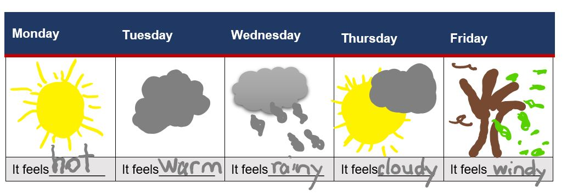

Look at this weather chart. Is this like the weather that you have had at home?

Search in old magazines for some pictures of people outside in different kinds of weather - a sunny day, a cold day and a rainy day.

Cut pictures out and glue them onto the next 3 pages with the words that match the weather.

Sunny weather

Cold weather

Rainy weather

Sunny, cold and rainy weather aren’t necessarily consistent in their presence or mutually exclusive. E.g., it can be sunny and cold, cloudy and hot, raining and hot. etc. What are some ways we can describe weather for consistency of understanding?

## Activity 2

During this activity you will think about where you play and measure it.

 Resources – coloured pencils, glue and scissors (if taking a photo)

### Let’s talk about your play place

Where do you play outside? Draw a picture or glue your photo of you and your outside play space here. Label the objects in your play space.

How many of your big steps is your outside play space on the longest side? ___________

How many of your big steps is your outside play space on the shortest side? ___________

How many big steps from the biggest object to the smallest object? __________________

Which object is the closest to you? ___________________________________

## Activity 3

During this activity you will think about your favourite toy, measure it and use your imagination.

 Resources – coloured pencils, a large spoon from the kitchen

### Let’s talk about your toys

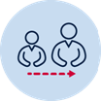 Talk to your parents about these questions.

* what are their favourite toys?
* do your toys need to be protected from the weather?
* what would happen to your toy if it was left out in the hot/cold/wet weather?
* what would your toy need to protect it from the weather?

### Let’s measure your favourite toy

Draw your favourite toy here

How many spoons tall is your toy? _________________________________________

How many spoons long is your toy? _________________________________________

How many spoons wide is your toy? __________________________________________

### Let’s imagine about our favourite toy

imagine: if your toy was alive, what might it

* say about being left outside in the weather?
* think about being left outside in the weather?
* feel if it was left outside in the weather?
* do about being left outside in the weather?

Draw and write about your toy in Think, Feel, Say and Do.

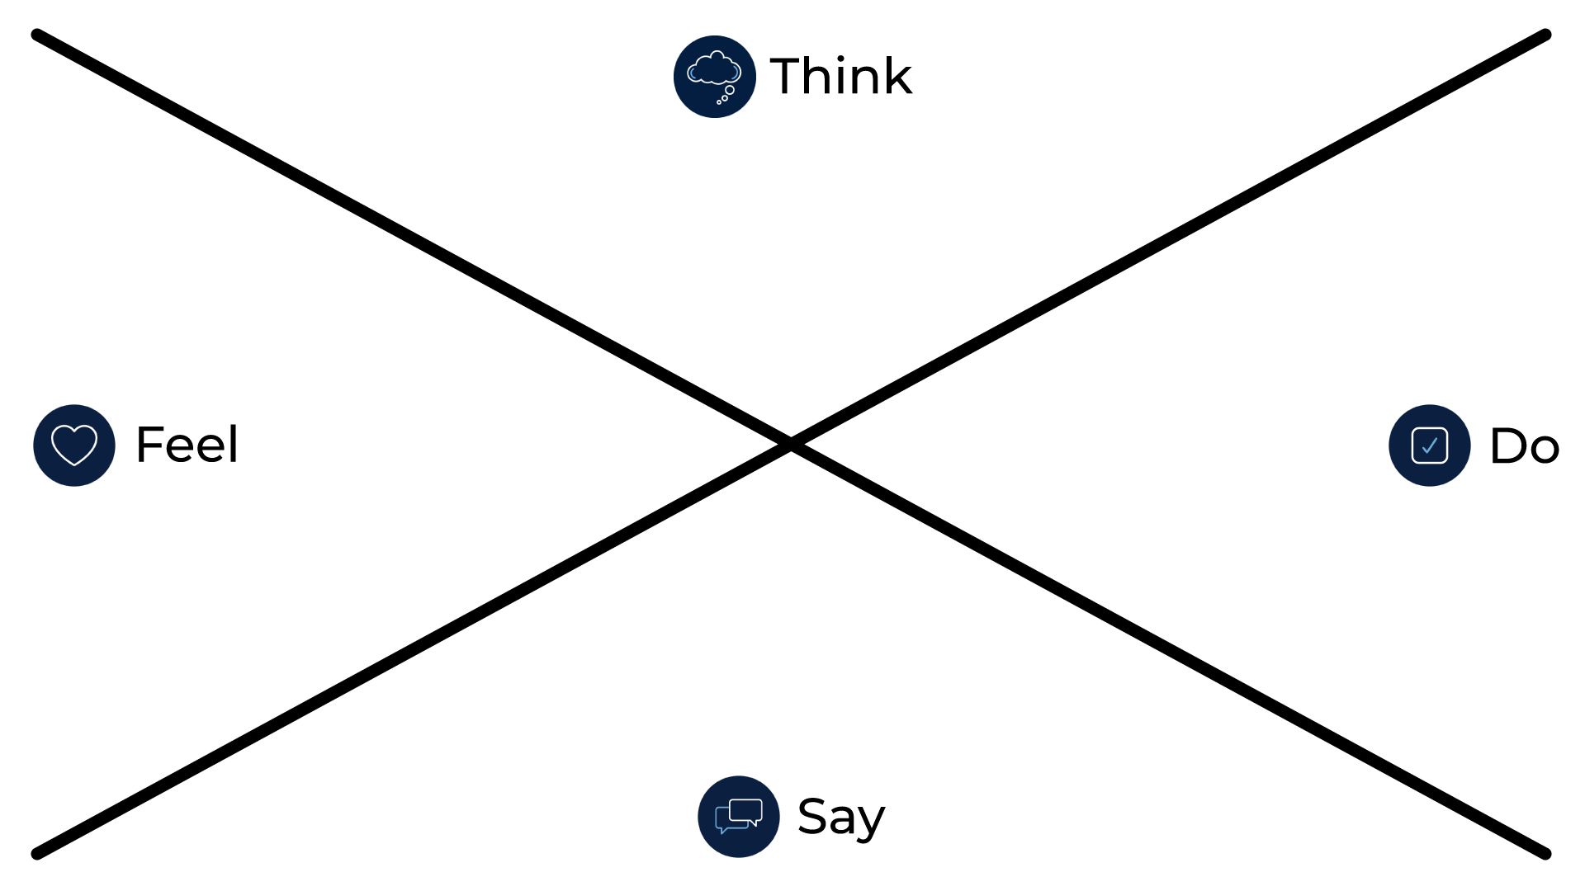

## Activity 4

### Let’s talk about our question and create ideas

During this activity you will create ideas about how to protect your favourite toy from the changes in the weather.

 coloured pencils

 Share this driving question:

How can I protect my favourite toy from the changes in the weather?

Talk to your parent/carer about

• what does it mean to protect something?

• what is your favourite toy?

• what does it mean for something to change?

• how does the weather change?

 **Quickly draw 4 crazy ideas to protect the toy from changes in weather in the boxes**

Crazy idea 1

Crazy idea 2

Crazy idea 3

Crazy idea 4

## ****Activity 5****

### **Let’s make and test your best idea**

During this activity you will make and test your best idea about how to protect your favourite toy from the changes in the weather.

a making box: containing materials found at home or school such as cardboard boxes, cylinders, tape, glue, pipe cleaners, materials, empty PET bottles

testing materials: watering can or hose, a warm place and a refrigerator

** Make (engineer) your best idea that protects your toy from the weather using materials found at home or school.**

**Test your innovation in all types of weather:**

* **a shower of rain - leave your toy under its protection and use a watering can or hose**
* **a hot day - leave your toy under its protection in the sun**
* **a cold day - leave you toy and its protection in the refrigerator for the night**

Draw a picture or glue a photo of your toy and its protection here.

in the rain

in the heat

in the cold

## Activity 6

### Let’s share your innovations

During this activity you will showcase your STEM innovation of how to protect your favourite toy from the changes in the weather.

showcase space (a special table in your play space)

Organise a showcase display of your STEM innovation in your outside play space

* prepare for the weather with the correct clothes and weather protection
* invite your family and toys to the showcase
* explain your learning from science and technology, engineering and mathematics.
* perhaps you might like to make invitations and set up a special STEM display space
* ask a family member to take some photos for you and print them out
* glue the photos here

**Activity 7**

### Reflection

Think about what you have learnt in this activity. Use the two stars and a wish structure to guide your reflection.

|  |  |  |
| --- | --- | --- |
| Star Something that went well! | Star  Something that went well! | Wish A goal for next time… |
|  |  |  |